Angular CRUD with Java middle ware application (Spring REST) with Router

5. Create a “Movie App” wherein movies could be maintained according to genres like Fiction, Drama and Satire. There is also a search option allowing to search for movies.

Use <Movies.java>

Refer below screen shot:

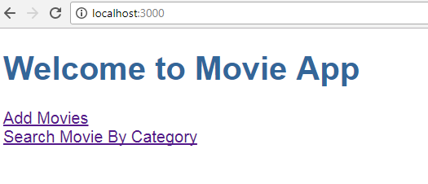

1. When the user clicks on “Add Movies” -> Allows a User to add a movie.

The user can add movie(s) depending on Genre (drop-down list loaded with values [Drama, Fiction, Satire])

The user could add multiple movies. On Adding Movies will be added in Database with the help of Spring Web services (Restful). Use Spring restful with JPA concept Refer below screen shot:

Refer below screens for validations:

1. When the user clicks on “Search Movie By Category” -> Allows user to search movie(s) by Category. [Depending on Genre (Drama,Fiction,Satire)]

There could be more than one movies depending on same Genre. Refer below screen shots:

Thus if Searching Movie on ‘Drama’ displays below Result:

Thus if Searching Movie on ‘Fiction’ displays below Result:

**Note:**

1. In above assignment movies are added via “Add Movies” and Searched via “Search Movie By Category”. ***These are different components.***
2. Make use of Angular Forms.
3. Make use of services.
4. Make use of Router Module. Which should be created as a separate module and included in the main App Module.
5. Use Spring restful & JPA concept to add movies & search movies.

All adding & searching movies done through database